Report

Executive summary
In this report, we would be using Tableau to visualise the data source provided by the company for analysis. This report will touch on five interactive dashboards that covers the different aspects of the business. These dashboards will cover the profit and sales overview, product analysis, customer analysis, market analysis, and profit forecast.
In profit and sales overview, it consists of the profit by country, sales by segment, and profit by year. This will give the general overview of the business’ performance from 2020 to 2023. In product analysis, we will cover the sales, profits, and ship mode of the categories. From customer analysis, we will learn more about our top customers, sales and profits of significant customers, and the ship mode by order priority. This allows us to analyse our customers’ behaviours and gain insights based on it. In market analysis, we will cover on the profit ratio by markets, and sales by segment and market. We will also cover the comparison of profits by the United States and Turkey by sub-categories. Lastly, this report will examine the forecast of the future performance of this company. The profit forecast will be done up to the fourth quarter of 2025.
After analysing the data, we will give some insights into the reasons of the occurrence of certain data and provide suggestions on ways to improve the numbers.

Table of Contents
1. Introduction 4
2. Story 4
2.1 Profit and Sales Overview 4
2.2 Product Analysis 5
2.3 Customer Analysis 6
2.4 Market Analysis 8
2.5 Forecast 9
3. Conclusion 10
4. Further recommendations 10

Introduction
This report discusses the performance of the company from 2020 to 2023. We were provided with a dataset that includes details on the orders made from 2020 to 2023. Using Tableau, we visualised the data through maps, bar charts, pie charts, line charts and more. Through the dashboards created, we would analyse the relationships found between various variables and provide important insights about the current and future of the company.

- Story

Profit and Sales Overview
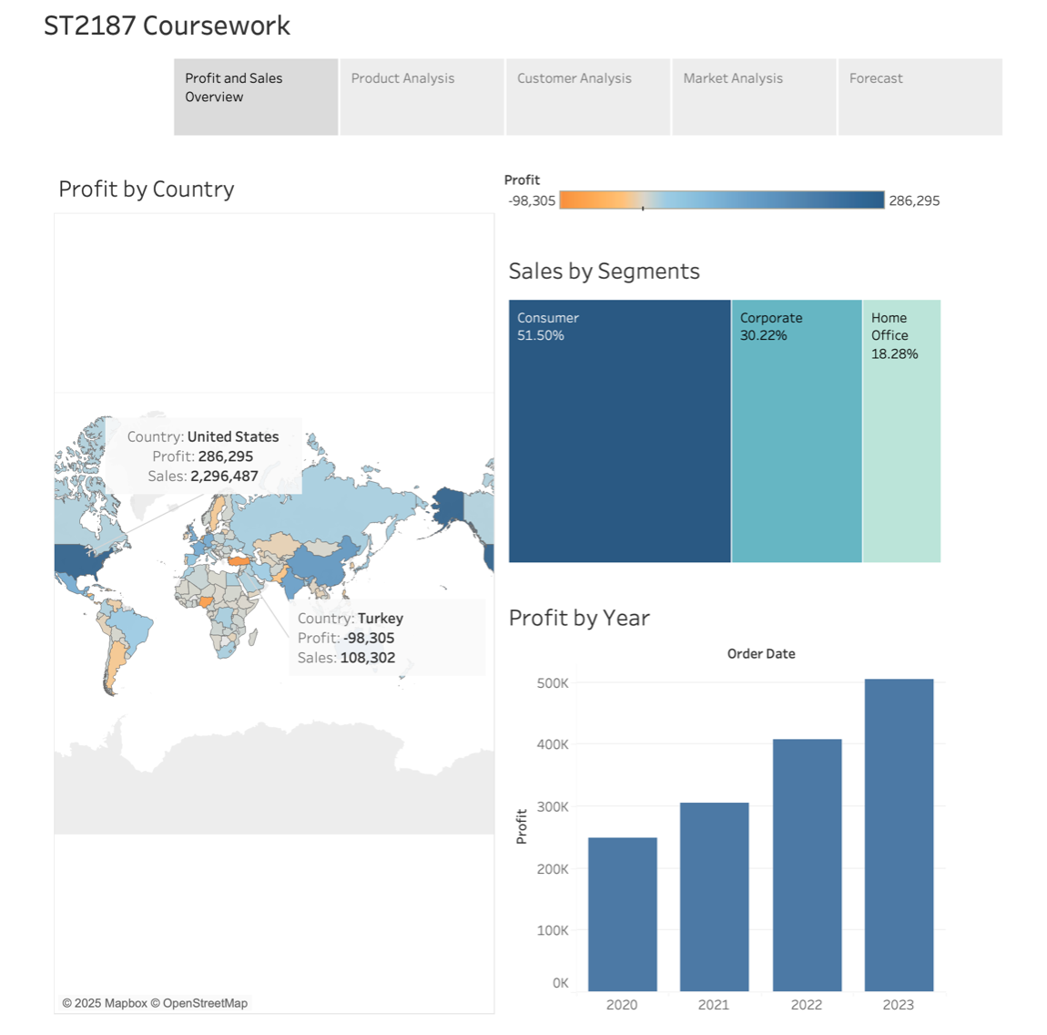
Observing the profits by country, the United States has the largest profit at $286,295 while Turkey has the largest loss at $98,305. Other than Turkey, several South American and other countries like Nigeria also saw losses in profits.
Observing the sales by segments, consumers had the largest sales percentage at 51.50%, followed by corporate at 30.22% and home office at 18.28%.
2023 had the highest profit at $504,411 while 2020 had the lowest profit at $248,941. From the bar chart, we can observe that there is an increasing trend in profits made from 2020 to 2023. This could be due to improvements in the company’s reputation. Customers who bought the products earlier in 2020 could have left good reviews on the products. Potential customers that saw these reviews would be further encouraged to buy from this company as other customers gave this company a good rating. Another reason could be the increase in types of products being sold over the years, causing in more products that suit our customers’ needs.

  - Product Analysis
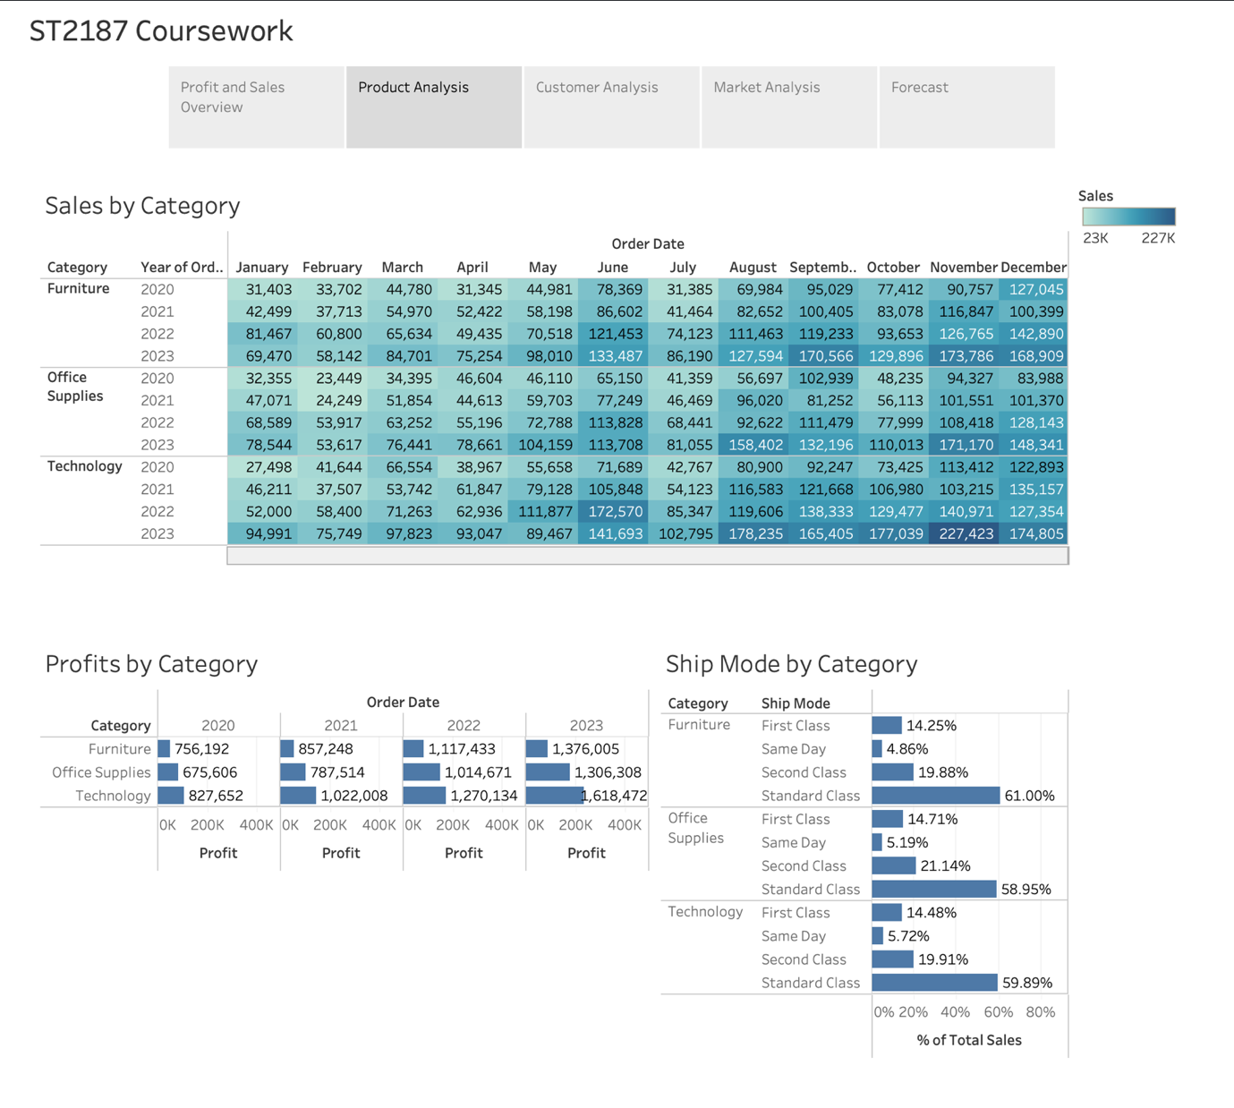
Observing the category sales chart, overall, November 2023 had the highest technology sales at $227,423, while February 2020 had the lowest office supplies sales at $23,449. Overall, sales tend to do better at the end of the year, from August to December, as compared to January to July. This could be due to the holiday season buying or the company increasing their efforts to close deals for the year.
From 2020 to 2023, technology has consistently made the most profits out of all the categories, followed by office supplies and then furniture. This would be due to the higher profit margins from technology and office supplies products than furniture products. In 2021, furniture had higher sales at $857,248 than office supplies at $787,514. However, in 2021, the profits from office supplies were higher than those from furniture. This consistently happened throughout the 4 years.
Regardless of category type, standard class shipping was chosen the most at approximately 60% of each category, followed by second class at approximately 20%, first class at approximately 15%, and lastly, same day shipping at approximately 5%. This is likely due to the cheaper shipping cost of standard class shipping as compared to the other higher priority ship modes.

  - Customer Analysis
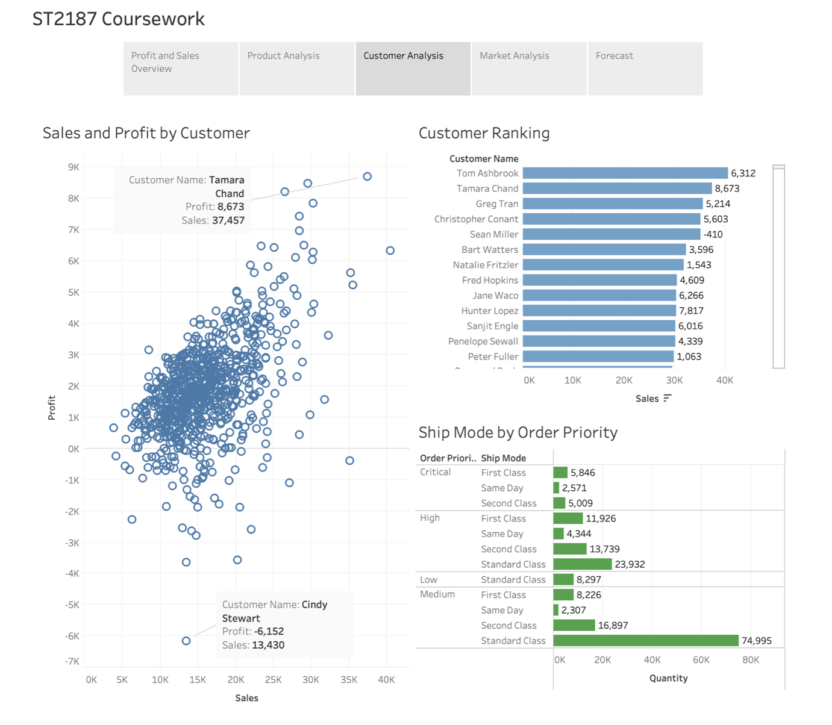
By customer ranking, Tom Ashbrook had the most sales at $40,488, followed by Tamara Chand with $37,457. However, Tamara Chand made the company more profits at $8,673 than Tom Ashbrook at $6,312. This could be due to Tamara Chand purchasing more products of higher profit margins such as technology products, while Tom Ashbrook purchased more products of lower profit margins such as furniture products. Interestingly, Sean Miller had high sales at $35,171, yet the company lost profits from him at a loss of $410. This could be because of the discount rates on his purchases were high enough that it surpassed the original profit margins, causing the company to make a loss from his sales.
Tamara Chand made the most profits for the company at $8,673, while Cindy Stewart caused a loss in profits at -$6,152. Cindy Stewart had $13,430 in sales, so, similarly to Sean Miller, she likely took advantage of the discount rates which caused the profit margin of the products she purchased to become negative.
From the ship mode by order priority chart, we can observe that most orders are of medium priority and standard class shipping at 74,995 orders while the least orders are of medium priority and same day shipping at 2,307 orders. For low priority orders, there is only one chosen shipping option of standard class. Interestingly, critical priority orders mostly chose first class shipping and second class shipping at 5,846 orders and 5,009 orders respectively while others chose same day shipping at 2,571 orders and no orders of standard class shipping. Since those orders are of critical priority, customers are willing to pay more for shipping to receive their products at an early date.

  - Market Analysis
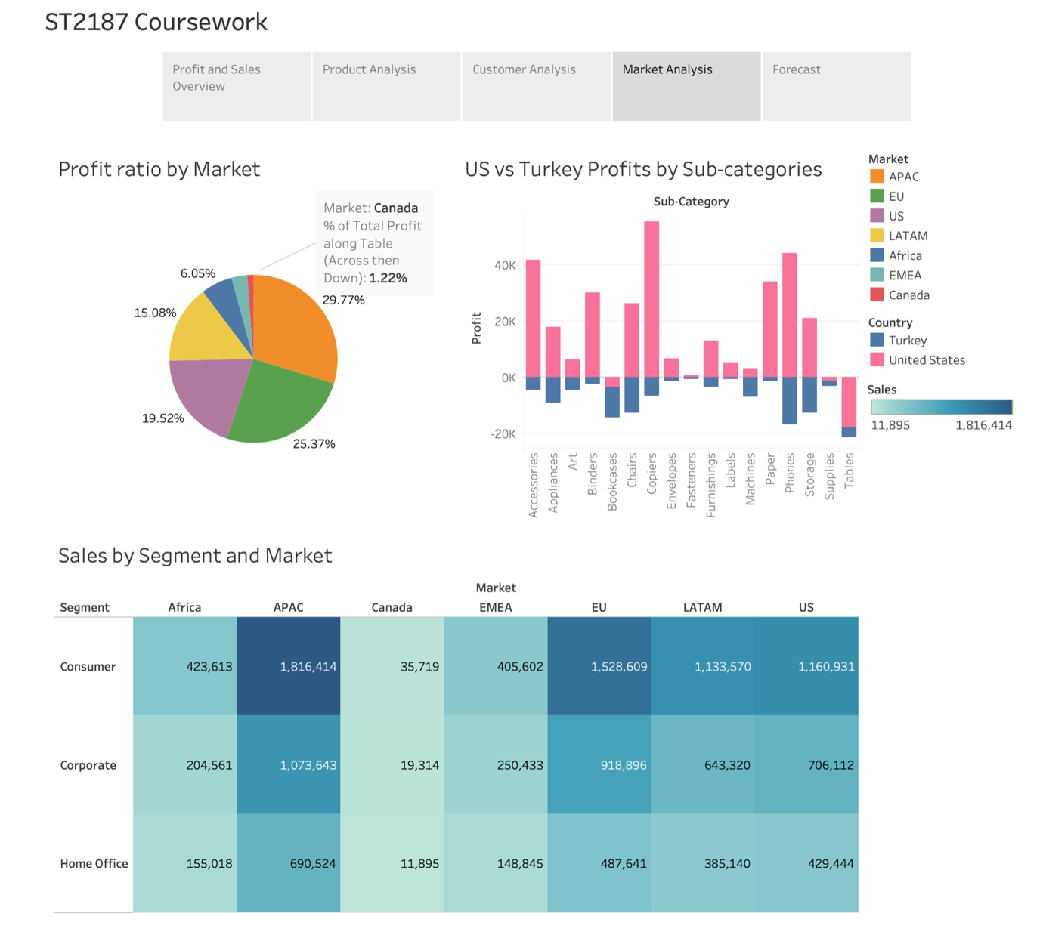
The most profits came from the APAC market at 29.77% of total profits, followed by the EU market at 25.37% and the US market at 19.52%. The least profits came from the Canadian market at 1.22% of the total profits. This could be because the Canadian market is smaller than that of APAC, EU and US so the products being purchased would naturally be lesser in volume. Overall, the highest sales were by the consumer segment of the APAC market at $1,816,414 while the lowest sales were by the home office segment of the Canadian market at $11,895. Across the three segments, the APAC market had the highest sales while the Canadian market had the lowest sales.
As mentioned before in the profit and sales overview, the United States (US) had the largest profit while Turkey had the lowest profits. Across all sub-categories, Turkey caused the company losses, with the most losses being phones at $16,665 and the least losses from labels at $420. However, the US mainly profited the company across most sub-categories. For the US, the most profit was copiers at $55,618 while the most losses was tables at $17,725. Since the US has a higher GDP per capita than Turkey, the people in the US have a higher purchasing power than the people in Turkey so more products would be purchased by the US, thus, more sales and profits by the US than Turkey.

  - Forecast
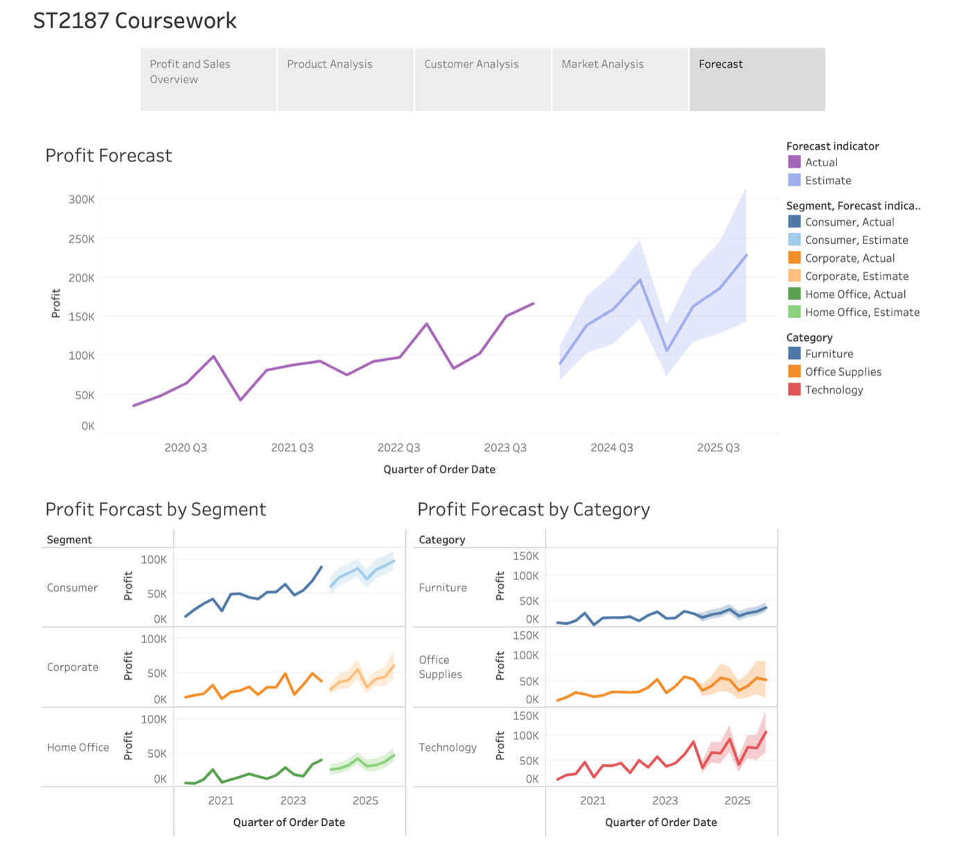
In the forecast, we are forecasting the performance of the company in the upcoming 2 years in quarters (Q). In 2024 Q1, the profits are forecasted to fall to $90,049 before increasing steadily to $197,128 in 2024 Q4. The profits will decrease again to $106,489 in 2025 Q1 and increase again to $228,782 in 2025 Q4. There is a consistent down period in Q1 so the company could implement new strategies to increase profits in Q1.
Overall, the profit forecast by segments indicates an increase in profits in the next 2 years. For home office, it has the smallest profit increase from $25,538 in 2024 Q1 to $46,608 in 2025 Q4. On the other hand, consumer has the largest profit increase from $59,764 in 2024 Q1 to $97,838 in 2025 Q4.
For the profit forecast by category, there is an overall increase in profits for all categories. Comparing 2024 Q1 and 2025 Q4, furniture increases the least in profits from $18,383 to $37,229 while technology increases the most in profits from $36,767 to $105,822. The large extent increase in profits from technology products could be due to an increase in demand for them as technology is so intertwined with people’s lives in the 21st century. Furniture are usually used for long periods of time so people usually do not have the need to purchase furniture every year, causing profits to increase to a smaller extent.

- Conclusion
In conclusion, the profits have increased from 2020 to 2023 and are still expected to increase in the next two years. Profits tend to be the best in the fourth quarter due to the holiday season causing a surge in people buying gifts for others. However, the first quarter profits are the lowest. Consumers made up the most sales at 51.50% as compared to the other segments. The company’s current biggest markets are APAC, EU and US. The three of these markets accounts for 74.66% of the company’s total profits from 2020 to 2023.
With higher profit margins, technology products are the largest profit source for the company. Standard class shipping is the most preferred ship mode regardless of category due to its lower cost compared to other ship modes. The only exception is when the order priority is critical, in which case, the preferred ship mode is first class or second class shipping.

- Further recommendations
To increase profits in the first quarter, we could create a new year’s sale so that we could keep up with the momentum from the previous year’s fourth quarter. To reduce loss in profits, we should lower the discount rates given to customers as it lowers the profit margin too much. Since Turkey has the highest profit loss, we could introduce better marketing techniques using the 5Ps marketing mix to market to them specifically. The 5Ps marketing mix consists of product, price, promotion, place, and people.

